** EXPERIMENT NUMBER 1.2 Four Probe Method**

**Student Name: Shinde Smita Shahaji UID: 20BCS4643**

**Branch: CSE (IOT) Section/Group: IOT (Group-B)**

**Semester: 2nd semester Date of Performance:18/02/2021**

**Subject Name: Quantum and Semiconductor physics lab**

**Four Probe Method**

**AIM OF THE EXPERIMENT –**

To determine the resistivity of semiconductors by four probe Method.

**APPARATUS –**

|  |  |  |  |
| --- | --- | --- | --- |
| **Sr.no** | **Equipment** | **Range** | **Quantity** |
| 1. | Power supply | 220V | 1 |
| 2. | Oven | 0-to-200-degree Celsius | 1 |
| 3. | n-type crystal | NA | 1 |
| **4.** | Milli-Ammeter & milli-Voltage | 0-20mA & 0-250mV | 1 |

**OBSERVATIONS-**

1. Material used for the experiment: =Silicon
2. Distance between the probes(s) =0.2cm
3. Thickness used for the experiment: =0.05cm
4. Current(I) used for the experiment: =45mA(constant)



1



|  |  |  |  |  |  |
| --- | --- | --- | --- | --- | --- |
| **Sr.no** | **Temp.**  (°C ) | **Temp.**  **(k)** | **Voltage (mV)** | **Current I (mA)** | **Resistivity**  **ρ(ohm cm)** |
| 1. | 25.5 | 298 | 5.663 | 45 | 26.8396 |
| 2. | 30 | 303 | 5.393 | 45 | 25.5598 |
| 3. | 35 | 308 | 5.117 | 45 | 24.2497 |
| 4. | 40 | 313 | 4.863 | 45 | 23.0456 |
| 5. | 45 | 318 | 4.629 | 45 | 21.9363 |
| 6. | 50 | 323 | 4.413 | 45 | 20.9123 |
| 7. | 55 | 328 | 4.213 | 45 | 19.9652 |
| 8. | 60 | 342 | 4.028 | 45 | 19.0875 |

**CALCULATIONS-**

|  |
| --- |
| **f(w/S) =5.89** |

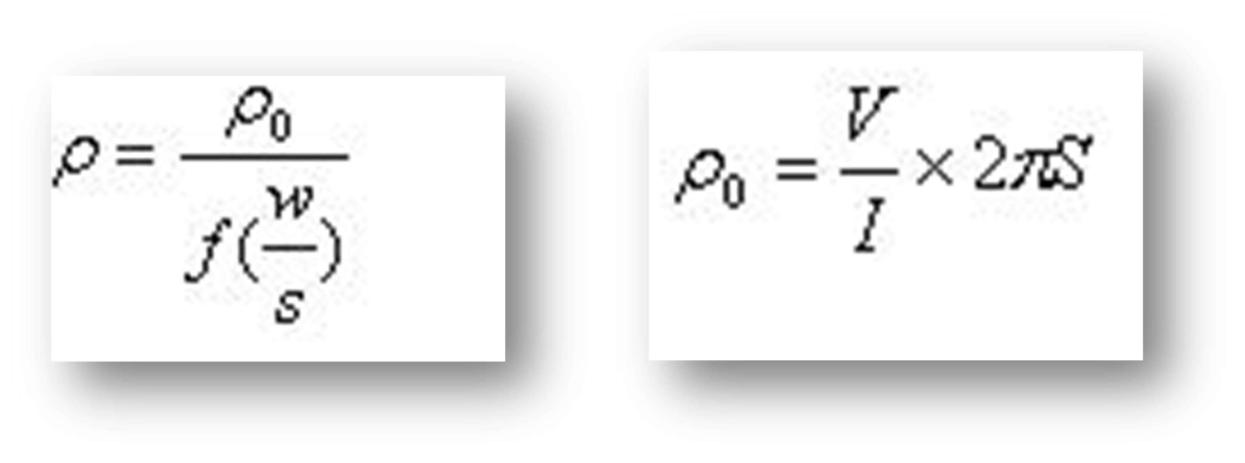



2

1. Calculations for Resistivity :- V=5.663mV

I=45mA S=0.2cm

Ρ0 = 5.663 (mV)/45(mA) X 2 X 3.14 X 0.2 cm

**Ρ= 26.8396**

1. Calculations for Resistivity :- V=5.393mV

I=45mA S=0.2cm

Ρ0 = 5.393 (mV)/45(mA) X 2 X 3.14 X 0.2 cm

**Ρ= 25.5598**

1. Calculations for Resistivity :- V=5.117mV

I=45mA S=0.2cm

Ρ0 = 5.117 (mV)/45(mA) X 2 X 3.14 X 0.2 cm

**Ρ= 24.2497**

4)Calculations for Resistivity :- V=4.863mV

I=45mA S=0.2cm

Ρ0 = 4.863 (mV)/45(mA) X 2 X 3.14 X 0.2 cm

**Ρ= 23.0456**

5)Calculations for Resistivity :- V=4.629mV



3



I=45mA S=0.2cm

Ρ0 = 4.629 (mV)/45(mA) X 2 X 3.14 X 0.2 cm

**Ρ= 21.9363**

6)Calculations for Resistivity :- V=4.413mV

I=45mA S=0.2cm

Ρ0 = 4.413 (mV)/45(mA) X 2 X 3.14 X 0.2 cm

**Ρ= 20.9123**

7)Calculations for Resistivity :- V=4.213mV

I=45mA S=0.2cm

Ρ0 = 4.213 (mV)/45(mA) X 2 X 3.14 X 0.2 cm

**Ρ= 19.9652**

**8)**Calculations for Resistivity

:- V=4.028mV

I=45mA

**S**=0.2cm

Ρ0 = 4.028 (mV)/45(mA) X 2 X 3.14 X 0.2 cm

# Ρ= 19.0875

# 



4



# PERCENTAGE ERROR-

# NO

**GRAPH (ATTACH IF ANY)-**

**NO**

**SOURCES OF ERROR-**

* 1. The resistivity of the material should be uniform in the area of measurement.
  2. The surface on which the probes rest should be flat with no surface leakage.
  3. The simulation software don’t work uniformly we have to reload it many times and then it does.

# RESULTS AND DISCUSSION-

## Resistivity of semiconductor = **21.96** ohm-cm at 50°C.

* The resistivity decreases exponentially with the increase in Temperature that is as at low temperatures resistivity is more and at high temperatures the resistivity is less.



5



6



**LEARNING OUTCOMES**

* + 1. It will provide the modest experience that allows students to develop and improve their experimental skills and develop ability to analyze data.
    2. Ability to demonstrate the practical skill on measurements and instrumentation techniques of some Physics experiments. Students will develop the ability to use appropriate physical concepts to obtain quantitative solutions to problems in physics.
    3. Students will demonstrate basic experimental skills by setting up laboratory equipment safely and efficiently, plan and carry out experimental procedures, and report verbally and in written language the results of the experiment.
    4. Students will develop skills by the practice of setting up and conducting an experiment with dueregards to minimizing measurement error

**EVALUATION COLUMN (To be filled by concerned faculty only)**

|  |  |  |  |
| --- | --- | --- | --- |
| **Sr. No.** | **Parameters** | **Maximum Marks** | **Marks Obtained** |
| 1. | Worksheet completion including writing learning objectives/Outcomes. (To be  submitted at the end of the day) | 10 |  |
| 2. | Post Lab Quiz Result. | 5 |  |
| 3. | Student Engagement in Simulation/Demonstration/Performance and Controls/Pre-Lab Questions. | 5 |  |
| 4. | Total Marks | 20 |  |
| 5. | Teacher’s Signature (with date) |  | |